A Leakage-Audited Workflow for Calibrated Short-Horizon Equity Direction Forecasting from Floorsheet Data: A NEPSE Case Study
Tulasi Dahal and Kishor Basyal
Corresponding author: tdahal2012@gmail.com

Abstract—Short-horizon direction forecasts for thinly traded equity markets are easily overstated by look-ahead features, overlapping labels, selection on the test period, and accuracy figures that hide how few predictions they cover. This paper documents a leakage-audited workflow from trade-level data of the Nepal Stock Exchange (NEPSE) to calibrated forecasts at 1, 3, 5 and 10 sessions. A total of 91,048,648 floorsheet trades are validated and globally de-duplicated (39,500 copies removed), aggregated to 360,943 eligible security-sessions from 362 ordinary shares, and combined with adjusted prices and point-in-time fundamentals into 60 predictors. Evaluation uses expanding-window walk-forward validation with a 25-session embargo, ten leakage checks, and a 250-session final test scored once after the primary method is locked. Five scikit-learn base learners feed four ensembles and two calibrators. On the final test, the locked log-loss-weighted blend reaches 58.99% accuracy at one session (majority baseline 55.34%, ROC-AUC 0.608); at 3, 5 and 10 sessions accuracy is not distinguishable from the base rate. Accuracy at confidence ≥ 0.70 is 81.1% at one session, but on only 243 predictions (0.40% coverage), 69.5% of them on one date; the 95% interval (63.3%–85.2%) includes values below 70%, and a net-of-cost backtest is negative at one session. CatBoost, LightGBM, XGBoost and Transformer code is included but was not executed; all results are for scikit-learn stand-ins.
Index Terms—equity direction forecasting, walk-forward validation, data leakage, probability calibration, selective prediction, ensemble learning, floorsheet data, NEPSE.

I. INTRODUCTION
Reported accuracy for short-horizon equity-direction models is easy to overstate. Features may use information that was not available at the forecast origin, labels that span several sessions overlap across neighbouring training and test rows, models and confidence thresholds are often chosen on the period that is later reported, and a high accuracy at a high confidence level can describe a handful of predictions on a single day [13]. These risks are acute for the Nepal Stock Exchange (NEPSE), where daily price limits, thin trading in many securities and gaps in published trade records mean that data-preparation choices can move results as much as the choice of learner.
This paper documents and evaluates a complete workflow for NEPSE. It starts from 91,048,648 floorsheet trade records, removes duplicate and invalid records, aggregates trades to a daily security panel, combines them with adjusted prices and point-in-time fundamentals into 60 predictors, and forecasts the direction of the next 1-, 3-, 5- and 10-session return. Five base learners are combined by four ensembles and two probability calibrators under expanding-window walk-forward validation with an embargo; the method for each horizon is fixed on development data and then scored once on 250 untouched sessions. Reporting follows what the evidence can support: overall accuracy against the majority-class baseline, proper scoring rules and calibration, accuracy at each confidence level together with its coverage and date concentration, paired forecast-comparison tests, and a net-of-cost backtest.
The scope is deliberately bounded. The study introduces no new learning algorithm or database system. The reported results were produced with scikit-learn learners (histogram gradient boosting, extremely randomized trees, logistic regression and two neural networks); implementations of CatBoost, LightGBM, XGBoost, a Transformer and a TFT-style network are part of the released pipeline but were not executed in this run, so no result is attributed to them. The evidence comes from one exchange and one 250-session test window, and none of the classification results is evidence of trading profitability.

A. Research Questions
The study investigates one overarching research question and three supporting questions:
- Main RQ: To what extent can calibrated ensembles of heterogeneous learners, trained on a leakage-audited floorsheet-derived panel, forecast the direction of NEPSE security returns at 1, 3, 5 and 10 sessions better than a majority-class baseline?
- RQ1: How do the base learners (tree ensembles, a linear model and neural networks) differ across horizons in out-of-fold and final-test performance?
- RQ2: Do the average, weighted, stacking and regime-aware ensembles, and Platt or isotonic calibration, improve log loss, accuracy and calibration over the best single learner and over the base rate, and are the differences statistically distinguishable?
- RQ3: What accuracy–coverage trade-off does confidence-based selection produce, can a 70% selective accuracy be established, how concentrated in time are the selected predictions, and do they survive transaction costs?

B. Contributions and Scope
- A cleaned and reconciled NEPSE panel: 91,048,648 floorsheet trades validated, 39,500 duplicate transactions removed globally, dealer codes retained, and 360,943 eligible security-sessions from 362 ordinary shares, with delisted companies retained from floorsheet prices.
- Point-in-time predictors: 60 predictors in eight families, with fundamentals usable only from quarter end plus 45 days, and a documented audit of why two supplied sources (single-period fundamental snapshots and a prediction feature store) cannot be used without look-ahead.
- A leakage-audited chronological protocol: a 504-session first window, eight expanding folds, a 25-session embargo, ten passed checks including a truncation-and-recompute test, a selection file hashed before a 250-session final test, and nested evaluation of ensembles and calibrators.
- A comparison of nine learners and ensembles with Platt and isotonic calibration, using session-block bootstrap intervals, Diebold–Mariano tests with HAC variance and Holm correction, and feature-family permutation importance.
- A selective-prediction analysis that reports every confidence level with its coverage, interval and date concentration, and a net-of-cost long-only backtest with a random-selection placebo.
- A resumable pipeline of 13 stages plus an optional importance stage, whose stage reports supply the figures reported here.
The scope is bounded to NEPSE. The empirical claims concern 250 final-test sessions (12 October 2025–5 November 2026) and the scikit-learn model family. The study is not a portfolio-profitability, cross-market or deployment study, and the earlier companion inference prototype, which accepts engineered CSV input for a 53-feature schema, has not been updated to the 60-predictor panel.

II. RELATED WORK AND RESEARCH POSITIONING
The cited financial-market literature provides the application context for this workflow. Research on emerging equity markets emphasizes that market integration, volatility, and liquidity conditions can differ from those observed in developed markets. Bekaert and Harvey [11] document distinctive volatility characteristics in emerging equity markets, while Bekaert, Harvey, and Lundblad [12] examine liquidity and expected returns. These studies motivate market-specific empirical evaluation; they do not, by themselves, prescribe the data contract or evaluation protocol implemented here.
Prior stock-forecasting studies examine a range of statistical and machine-learning approaches. Crisostomo et al. [4] examine linear regression, artificial neural networks, and random forests for Nike closing-price prediction. Amruth et al. [7] compare classifiers using price, volume, turnover, and technical indicators. These works motivate careful definition of the forecast target and the availability of predictors at the forecast origin.
Sekhar and Narasimhulu [9] evaluate ensemble and deep-learning approaches using market and sentiment inputs, while Kani et al. [10] combine random-forest feature selection with LSTM sequence modelling. Other studies compare forecasting methods across securities and feature configurations [1]–[3], [5], [6], [8]. Their markets, datasets, targets, and validation protocols differ from the NEPSE security-session panel used in this paper; their numerical results are therefore not directly comparable.
The present work is positioned at the evaluation boundary rather than at the model frontier. Financial machine-learning practice recommends purging and embargoing observations whose labels overlap the evaluation window [13], comparing forecasts with tests that allow for serial dependence and many comparisons [14]–[16], and reporting calibration rather than accuracy alone [17]–[19]. Selective prediction, in which a classifier abstains below a confidence threshold, trades coverage for accuracy and must be reported together with coverage [20]. Convex blending and stacked generalization [21] are the ensemble forms used here, and extremely randomized trees [22] and histogram-based gradient boosting [23] are among its base learners. The cited bibliography primarily establishes the forecasting context; it does not provide a benchmark for the NEPSE results below. The paper therefore makes an applied-evidence contribution and does not claim a new learning algorithm or database architecture.

III. HETEROGENEOUS DATA, PANEL CONSTRUCTION AND NEPSE CASE STUDY

A. NEPSE as the Case-Study Setting
The Nepal Stock Exchange is used as a single-exchange case through which to study data preparation and evaluation for short-horizon forecasting. “Emerging-market setting” describes the research context; it is not a claim that NEPSE belongs to a particular index provider's formal classification, and the study makes no investability assessment. NEPSE applies daily price limits of ±10%, many listed securities trade thinly, and public floorsheets record every transaction with broker identifiers.
The case-study rationale is methodological. The panel combines price and return features, volume and liquidity measures, broker-activity features computed from trades, market state and quarterly fundamentals. These heterogeneous sources require stable identifiers, explicit availability dates and a documented treatment of gaps; each requirement is addressed below and audited in Section V.

B. Source Data and Cleaning
The floorsheet archive consists of three zip parts covering 1 October 2018 to 5 November 2026 (41,169,555, 19,364,427 and 30,514,666 rows). All 91,048,648 rows were checksummed, verified by CRC and parsed by streaming. Of the rows dropped, 8 had a non-positive quantity, rate or amount; none lacked a required field or a usable broker identifier. Because the transaction number encodes the trade month, duplicates were removed globally: 39,500 exact copies, all in part 3 (July 2026) and none with conflicting contents, leaving 91,009,140 trades (99.957%). Alphanumeric broker codes (33,758 fields, all “D01”) are real dealer trades and were kept under a new identifier rather than discarded as invalid. A further 102,076 trades from October to December 2018 carry an older transaction-number format, and 710 rows have an amount that differs from quantity × rate by more than NPR 1; both groups were kept and flagged. Trade time is empty in 79.4% of rows, so intraday order follows the transaction number. After aggregation no OHLC violation remains and trade counts reconcile with the daily aggregates (405,370 symbol-sessions, 655 symbols, 1,840 sessions).
Three auxiliary sources were parsed, de-duplicated and audited for look-ahead (Table II). Adjusted OHLCV (540,011 rows, 479 symbols including the NEPSE index and 16 sub-indices) is back-adjusted for corporate actions and lists currently listed symbols only, so floorsheet prices supply the 82 delisted or merged ordinary shares. Quarterly fundamentals (5,625 reports, 270 companies) carry a date column that lies 29–31 days before the quarter ends in every row, so it is not a publication date; reports are used only from quarter end plus 45 days. The nine single-period fundamental tables and the supplied prediction feature store (148,289 rows, 101 symbols) were audited and excluded.

C. Universe, Observation Unit and Floorsheet Gaps
Instruments were classified as ordinary shares (369), promoter shares (143), debenture or fund series (112) and closed-end mutual funds (30); only ordinary shares are modelled. A security-session is eligible if the security traded and did so on at least 10 of its last 20 sessions (counting the current one), has a 60-session return, has traded in at least 30 sessions to date (needed by the sequence-window model), and falls on or after 1 October 2018. This yields 360,943 eligible rows from 362 securities over 1,855 sessions. Close-to-close moves above 11%, beyond the ±10% circuit limit, were treated as unadjusted corporate actions or bad prints and neutralised on 225 symbol-sessions.
The floorsheet is largely absent from the source archive in several months. Fig. 1 shows the share of eligible security-sessions with floorsheet-derived predictors: it is 92–100% in 83 of 97 months, 9–14% from April 2022 to March 2023, 43% in February 2022 and 54% in March 2024. Prices for listed stocks come from the complete adjusted OHLCV table, but the 20 floorsheet-derived predictors are left missing in those months rather than imputed; overall 88.5% of eligible rows have floorsheet features and 72.4% have fundamentals.
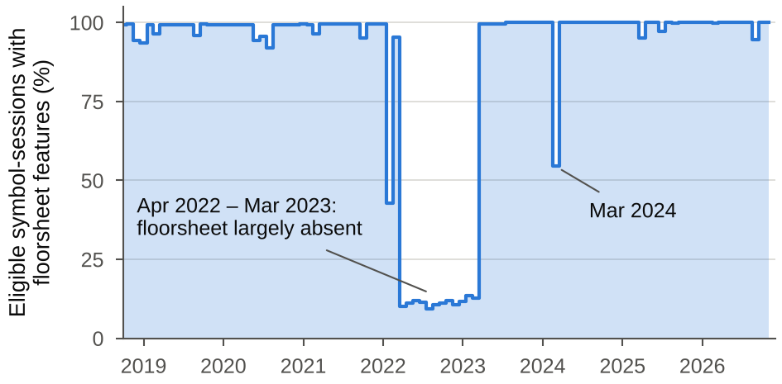
Fig. 1. Share of eligible security-sessions with floorsheet-derived predictors, by month. The archive is largely absent from April 2022 to March 2023 and partly absent in February 2022 and March 2024; those predictors are left missing, not imputed.

D. Predictor Families
The 60 predictors fall into eight families (Table I). Fifty-three core predictors describe price, return, volatility, candle shape, trend, oscillators, range position, liquidity, floorsheet and broker concentration, and NEPSE market state; seven point-in-time fundamentals are added. Twenty predictors depend on floorsheet trades. Every predictor at session t uses only data available at the close of session t.
TABLE I. PREDICTOR FAMILIES (60 PREDICTORS)
Family | n | Predictor fields
Returns and momentum | 11 | ret1, ret2, ret3, ret5, ret10, ret20, ret60, rel_ret5 (vs. market), drawdown60, dist_high252, dist_low252
Volatility and range | 7 | vol5, vol10, vol20, vol60, hl_range, atr14_pct, bb_pos
Candle shape and gaps | 4 | oc_ret, close_vwap, gap, close_pos
Trend and oscillators | 7 | ma5_dist, ma10_dist, ma20_dist, ma50_dist, rsi14, macd_hist, stoch_k14
Liquidity and volume | 9 | volratio_1_20, volratio_5_20, log_amount, log_trades, amihud20, stale20, turnover_trend, avg_trade_size, trades_ratio20
Broker concentration | 13 | buyer_hhi, seller_hhi, buyer_top1, seller_top1, buyer_top5, seller_top5, log_buyers, log_sellers, self_share, large_share, size_cv, broker_imbalance, buyer_hhi_chg5
NEPSE market state | 2 | mkt_ret1, mkt_vol20
Fundamentals (point-in-time) | 7 | fund_ep, fund_bp, fund_roe, fund_de, fund_rev_growth, fund_eps_yoy, fund_age

E. Source Mapping and Evidence Status
TABLE II. SOURCE MAPPING AND EVIDENCE STATUS
Source | Role in this study | Evidence and limitation
Floorsheet trades (3 zip parts) | 20 predictors, daily aggregates, prices of delisted shares | 91,048,648 rows parsed; 39,500 duplicates and 8 invalid rows removed; trade time missing in 79.4%; archive incomplete in 14 of 97 months.
Adjusted OHLCV (540,011 rows) | Prices, returns, volume and targets for 287 listed shares | Back-adjusted; lists current symbols only; 22,628 rows violate high–low ordering (87% before 2019); 19,433 modelled bars were repaired.
Quarterly fundamentals (5,625 reports) | 7 predictors, usable from quarter end + 45 days | Table date precedes quarter end in 100% of rows, so the lag is an assumption; covers 72.4% of eligible rows.
Nine single-period fundamental tables | Not used | One latest fiscal period per company; applying it to earlier dates leaks future information.
Prediction feature store (148,289 rows) | Not used | Fundamental columns switch before the quarter ends in 99.7% of switches: look-ahead.

F. Point-in-Time and Survivorship Controls
Four controls keep the panel point-in-time. First, targets are built only from future adjusted prices and are never features. Second, rolling features use past sessions only, which the audit verifies by rebuilding the panel from data truncated at a cutoff and recomputing every feature (maximum absolute difference 0 over 60 features and 263,496 rows). Third, fundamentals enter at quarter end plus 45 days, and earnings-to-price and book-to-price are rebuilt from the quarter-end price and the adjusted return since, because the supplied P/E multiplied by EPS reproduces the raw quarter-end price within 2% for 86.8% of reports but for only 17.8% at the table's date column. Fourth, delisted and merged companies stay in the panel with floorsheet prices, which reduces survivorship bias, although the jump rule above is the only price adjustment available for them. These controls establish conformance to a point-in-time design; they do not prove that every upstream source record is correct.

IV. DIRECTION TARGETS AND MODEL-OUTPUT FORMULATION

A. Multi-Horizon Direction Targets
Let i denote a security and t an exchange session on which it traded. Let P_{i,t} be its adjusted close (back-adjusted OHLCV for listed shares, chained floorsheet prices for delisted shares). For a horizon h ∈ {1, 3, 5, 10} sessions, the forward return and the binary target are:
R^{h}_{i,t} = P_{i,t+h} / P_{i,t} − 1, y^{h}_{i,t} = 1[R^{h}_{i,t} > 0] (1)
Horizons count exchange sessions, not calendar days. Rows with exactly zero return are excluded rather than assigned to the down class; they are 5.6%, 1.6%, 1.0% and 0.5% of eligible rows at h = 1, 3, 5 and 10. The labelled up-rate is 45.5%, 45.7%, 46.2% and 46.6%, so the majority class is down and a constant “down” forecast is the baseline each model must beat. Rows whose target lies beyond the end of the data are unlabelled by construction, and labels with h > 1 overlap across consecutive sessions.

B. Base-Learner Probabilities
Let x_{i,t} ∈ ℝ⁶⁰ be the predictor vector. Each base learner j returns an estimate of the probability of an up move:
p^{h}_{j,i,t} = f^{h}_{j}(x_{i,t}), j ∈ {HGB, ET, LR, MLP, WMLP} (2)
HGB is histogram gradient boosting, ET extremely randomized trees, LR logistic regression, MLP a multilayer perceptron and WMLP a perceptron that also receives 12 key predictors from the 19 preceding observations of the same security. Missing predictors are handled natively by HGB, by median imputation in ET and LR, and by median-centred robust scaling with zero-filling and two missing-value flags in the networks. The MLP and WMLP each produce all four horizons from one network.

C. Ensembles, Calibration and Confidence
The weighted blend, the stacked logistic regression and the regime-aware stacker combine the five probabilities (the horizon index is dropped for readability). The weighted blend is
p̂ = Σ_{j} w_{j} p_{j}, w_{j} ≥ 0, Σ_{j} w_{j} = 1 (3)
with w chosen to minimise log loss on earlier out-of-fold probabilities by sequential least-squares programming. Stacking fits
p̂ = σ(β₀ + Σ_{j} β_{j} logit(p_{j})) (4)
and the regime-aware stacker fits separate β for four regimes defined by the sign of the 60-session NEPSE index return and by whether 20-session market volatility exceeds its training median; regimes with fewer than 3,000 training rows fall back to the pooled stacker. The simple average is the equal-weight case of (3). Platt scaling [17] and isotonic regression [18] recalibrate p̂ on earlier second-level outputs:
p̃ = σ(a + b logit(p̂)) or p̃ = g(p̂) (5)
with g a monotone step function bounded to [0.005, 0.995]. The predicted class is up when the probability exceeds 0.5. Confidence, coverage and selective accuracy at a threshold τ are
c = max(p̂, 1 − p̂), κ(τ) = Pr(c ≥ τ), A(τ) = Pr(ŷ = y | c ≥ τ) (6)
where κ is coverage and A is selective accuracy. In this paper the “70% confidence level” is the operating point τ = 0.70, not a claim that overall accuracy is 70%. Confidence is a model-derived score and no guarantee of a realised correctness rate; its reliability is assessed by the expected calibration error (ECE, ten equal-width bins) and reliability diagrams [19].

V. CHRONOLOGICAL VALIDATION AND TEMPORAL-INTEGRITY CONTROLS
All evaluation is chronological. The 1,855 eligible sessions are split into a development period and a final test of 250 sessions (12 October 2025 to 5 November 2026; 64,387 rows), separated from development by a 25-session gap. Within development, eight expanding-window folds are used. The first training window holds 504 sessions and each validation block holds 131 sessions (134 for the last), with a 25-session embargo between the end of every training window and the next evaluation block. The embargo exceeds the longest label horizon of 10 sessions; the audited minimum gap between the last training label and the start of validation is 16 sessions (Table III). Fold 1 trains on October 2018–January 2021 and validates on February–September 2021; fold 8 trains to December 2024 (1,421 sessions) and validates on January–August 2025.
Base learners produce out-of-fold (OOF) probabilities on all eight folds. Ensemble weights and stackers for fold k are fitted only on first-level OOF predictions from earlier folds, and calibrators for fold k only on second-level outputs of folds 2 to k − 1, so every comparison uses folds 3–8 (4 April 2022–17 August 2025; 789 sessions; 163,145 to 167,291 labelled rows per horizon), where the full nested chain is available.
Before any test prediction was evaluated, the primary method per horizon (the ensemble or calibrated-ensemble candidate with the lowest OOF log loss) and the best single learner (the comparator) were written to a selection file whose SHA-256 digest was stored in a lock file together with the split-manifest digest. All base learners were then refitted on all development sessions, ensemble weights and calibrators were fitted on all development OOF outputs, and the test sessions were predicted once. The lock records 0 forced re-runs.
TABLE III. LEAKAGE AND SPLIT AUDIT (ALL TEN CHECKS PASSED)
Check | Result
Embargo covers label horizon | At least 16 sessions beyond the 10-session label reach; embargo 25 sessions
Validation blocks contiguous and non-overlapping | Blocks tile the development period
First training window | 504 sessions
Final test isolated | 25-session gap; test of 250 sessions
Development and test rows disjoint | 290,409 development rows; 64,387 test rows
No duplicate (symbol, session) | Unique keys
Targets unavailable in last h sessions | 0 labelled rows in the last 1, 3, 5 and 10 sessions
Truncation: same rows | 263,496 of 263,496 rows present in both builds
Truncation: look-ahead-free features | Maximum |difference| 0; 0 missing-pattern mismatches; 60 features × 263,496 rows
No suspicious feature–target correlation | Largest |corr| with the 1-session target 0.041 (ret2)

Confidence intervals use a circular moving-block bootstrap over sessions [24] with blocks of 20 sessions (300 replicates out of fold, 1,000 on the final test), which preserves cross-sectional and serial dependence. Log-loss differences between methods are compared with Diebold–Mariano tests on session-averaged losses, with a Bartlett-kernel (Newey–West) long-run variance [15] at lag max(h, 5) + 5 sessions, the small-sample correction of Harvey et al. [25] and a Student-t reference distribution; p-values are one-sided for the hypothesis that the first method has lower loss and are Holm-adjusted within the ten pre-specified comparisons per horizon on the final test (79 comparisons out of fold). Selective accuracy is tested against 70% by the share of bootstrap replicates that fall below 70%.

VI. BASE LEARNERS, ENSEMBLES AND CALIBRATION
The results in this paper come from the scikit-learn model family of the released pipeline [26]. It was used because the native gradient-boosting and deep-learning libraries could not be installed in the execution environment. The native family (CatBoost, LightGBM, XGBoost, a Transformer, a TFT-style network and a LambdaRank ranker) is implemented but was not executed, and no result below should be attributed to it (Section X).

A. Base Learners
TABLE IV. BASE LEARNERS (SCIKIT-LEARN FAMILY)
Learner | Configuration
HGB | HistGradientBoostingClassifier: 31 leaves, learning rate 0.05, L2 = 5, at least 200 samples per leaf, 80% feature subsampling, early stopping on the last 12% of training sessions (purged by 15 sessions).
ET | ExtraTreesClassifier: 200 trees, at least 100 samples per leaf, 30% of features per split, 50% bootstrap samples, median imputation; at most 150,000 sampled training rows.
LR | Median imputation, quantile transform to a normal distribution, L2 logistic regression (C = 0.1).
MLP | Robust-scaled inputs plus two missing-value flags; hidden layers 128–64 (ReLU, Adam, α = 10⁻³, batch 512); early stopping on a random 10% of training rows; at most 150,000 rows; one network with four outputs gives all horizons.
WMLP | As the MLP, with 12 key predictors from each of the 19 preceding observations of the same security added to the current 60; at most 120,000 rows.
Ranker | HistGradientBoostingRegressor on the within-session quintile of the forward return (sessions with at least 10 names); used for rank-IC and a top-10 backtest.
All learners are retrained on each expanding window with fixed random seeds. The early stopping of the MLP and WMLP uses scikit-learn's random hold-out, a less strict rule than the chronological hold-out used for HGB; it uses only rows inside the training window, so it cannot leak evaluation data.

B. Ensembles and Calibration
Table V shows the final blend weights fitted on all development OOF probabilities. Log-loss-optimal weights concentrate on the heavily regularised ExtraTrees and logistic learners as the horizon grows (ExtraTrees 44% at one session and 63% at ten; logistic 9% and 25%), while the two neural networks receive 13% at one session and 0.04% at ten, consistent with their poor calibration (OOF ECE 0.13–0.25).
TABLE V. FINAL BLEND WEIGHTS BY HORIZON (%)
Horizon (sessions) | HGB | ET | LR | MLP | WMLP
1 | 33.8 | 44.3 | 9.1 | 7.9 | 4.9
3 | 19.7 | 36.4 | 37.0 | 3.9 | 3.0
5 | 13.8 | 57.4 | 25.5 | 3.3 | 0.0
10 | 12.0 | 63.3 | 24.7 | 0.0 | 0.0

C. Native-Library Implementations Not Executed
The released pipeline also implements CatBoost [27], LightGBM [23] and XGBoost [28] classifiers with early stopping on the last 12% of training sessions, a Transformer encoder over 30-session sequences, a TFT-style network with variable selection and a LambdaRank ranker. They share the folds, embargo, ensembling, calibration and test protocol, so selecting the native family regenerates every table for the named algorithms. Histogram gradient boosting in scikit-learn is of the same family as LightGBM, but it is a different implementation; any statement about the named algorithms is untested here.

VII. IMPLEMENTED PIPELINE AND REPRODUCIBILITY
The workflow is implemented as 13 resumable stages plus an optional importance stage (Fig. 2, Table VI). Each stage writes a JSON report, and the final-test stage refuses to run again unless forced, in which case the re-run is recorded in the lock. Ingestion is checkpointed so that a 91-million-row archive is processed in bounded memory, and trades are stored in monthly buckets keyed by the month encoded in the transaction number, which makes global de-duplication exact. The same code path supports a core-only ablation (53 predictors) and the native model family. The pipeline code, split manifest, selection lock and stage reports form the reproducibility package of this study.
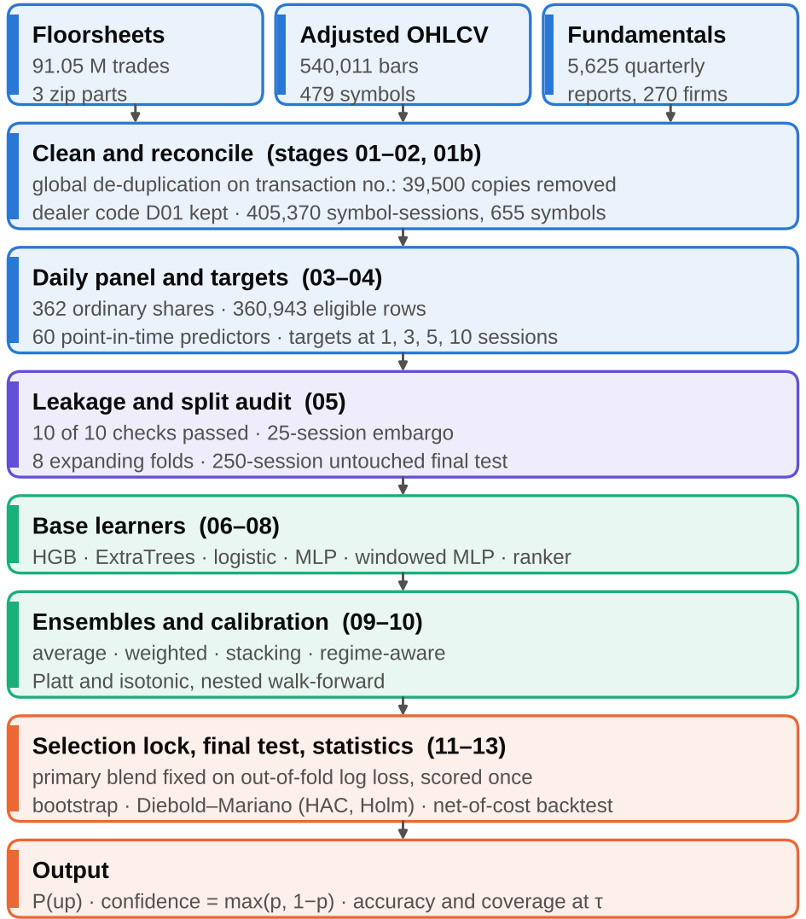
Fig. 2. Pipeline from raw floorsheet, price and fundamentals archives to calibrated forecasts and statistical tests. Stage numbers refer to Table VI.
TABLE VI. PIPELINE STAGES AND VALIDATION BOUNDARIES
Stage | Implemented operation | Boundary
01–02 | Checksums, CRC and schema of the archives; streaming parse; global de-duplication; daily aggregates | 91,048,648 to 91,009,140 trades; resumable
01b | Parse and audit OHLCV, fundamentals and feature-store dumps for look-ahead | Feature store and nine snapshot tables excluded
03–04 | Universe, adjusted bars, 60 predictors, four direction targets | Point-in-time by construction; flat outcomes excluded
05 | Leakage and split audit with truncation recompute | Ten checks; 25-session embargo
06–08 | Base learners, ranker, OOF predictions on eight folds | Scikit-learn family run; native family not run
09–10 | Average, weighted, stacking, regime-aware ensembles; Platt and isotonic calibration | Nested walk-forward; folds 3–8
11 | Metrics, block bootstrap, Diebold–Mariano tests, rank-IC | Holm correction
12 | Selection lock and single final-test run | Hashed selection; 0 forced re-runs
13 | Net-of-cost backtest, figures, report | Long-only; random placebo
14 | Feature-family permutation importance | Development folds 7–8 only

VIII. EXPERIMENTAL RESULTS

A. Development (Out-of-Fold) Results
Across folds 3–8 (789 sessions) the weighted blend reaches 57.1% accuracy at one session against a majority baseline of 54.8% (ROC-AUC 0.579, log loss 0.6786, ECE 0.0079) and exceeds the baseline in all six folds. At 3, 5 and 10 sessions its accuracy is 54.1%, 52.8% and 52.3% against baselines of 54.5%, 54.1% and 53.8%, with 1, 0 and 0 of six folds above the baseline, so no accuracy gain is supported there. ExtraTrees was the best single learner by OOF log loss at every horizon. At one session the blend improves on the base rate in log loss (Holm p = 0.0001) but its edge over ExtraTrees is not significant after correction (Holm p = 0.74).

B. Final-Test Results
On the untouched final test (12 October 2025–5 November 2026) the locked blend attains 58.99% accuracy at one session (95% CI 56.98%–60.90%) against a majority baseline of 55.34%, with ROC-AUC 0.608, log loss 0.6720 and ECE 0.0323 (Table VII). A constant forecast equal to the development up-rate scores a log loss of 0.6875. The blend's advantage of 0.0145 in session-averaged log loss is significant after correction (Holm p < 0.001; Table X), as is its advantage over the pre-specified comparator, ExtraTrees (0.0066; Holm p = 0.0002).
At three sessions the accuracy of 59.23% (95% CI 55.70%–62.56%) is not distinguishable from the 57.32% baseline (bootstrap p = 0.14), although log loss is better than the base rate (Holm p = 0.006). At five and ten sessions accuracy (58.3% and 55.3%) does not exceed the baselines (57.3% and 56.8%) and log loss does not beat the base rate (Holm p = 1.0). The test window is more favourable than the development average: three-session accuracy is 59.2% on the test but 54.1% out of fold, so a single window should not be generalised.
TABLE VII. LOCKED BLEND VERSUS THE MAJORITY BASELINE, OUT-OF-FOLD AND FINAL TEST
Sessions · split | n | Maj. % | Accuracy % [95% CI] | AUC | Log loss | ECE
1 · OOF | 163,145 | 54.8 | 57.1 [55.7, 58.5] | 0.579 | 0.6786 | 0.0079
1 · Test | 60,526 | 55.3 | 59.0 [57.0, 60.9] | 0.608 | 0.6720 | 0.0323
3 · OOF | 166,486 | 54.5 | 54.1 [51.8, 56.1] | 0.535 | 0.6888 | 0.0155
3 · Test | 62,864 | 57.3 | 59.2 [55.7, 62.6] | 0.610 | 0.6732 | 0.0488
5 · OOF | 166,932 | 54.1 | 52.8 [50.1, 55.6] | 0.525 | 0.6916 | 0.0220
5 · Test | 62,599 | 57.3 | 58.3 [53.7, 62.5] | 0.597 | 0.6801 | 0.0623
10 · OOF | 167,291 | 53.8 | 52.3 [49.2, 55.8] | 0.521 | 0.6956 | 0.0322
10 · Test | 61,681 | 56.8 | 55.3 [49.1, 60.9] | 0.584 | 0.6863 | 0.0732
OOF = folds 3–8 (block bootstrap, 300 replicates); Test = 250 untouched sessions (1,000 replicates). Maj. = accuracy of a constant majority-class forecast.
Table VIII compares all methods on the final test. The rows are descriptive: the primary method was fixed beforehand, and choosing among them after seeing the test would invalidate it. Of the four ensembles, the stacker has the lowest log loss at one, five and ten sessions, and the isotonic-calibrated blend has the lowest of all rows at one session (0.6707). HGB, the second-best single learner out of fold at one and three sessions, has a lower test log loss than the blend at those horizons (0.6710 and 0.6694 against 0.6720 and 0.6732), so the blend's advantage holds against the pre-specified comparator but not against the best learner in hindsight. The two neural networks are clearly worse (log loss 0.73–0.98) and badly calibrated (ECE 0.11–0.24), and the regime-aware stacker is worse than the pooled stacker at every horizon.
TABLE VIII. FINAL-TEST LOG LOSS AND ECE BY METHOD AND HORIZON
 | Log loss, horizon (sessions) |  |  |  | ECE, horizon (sessions)
Method | 1 | 3 | 5 | 10 | 1 | 3 | 5 | 10
Base rate | 0.6875 | 0.6844 | 0.6848 | 0.6860 | 0.006 | 0.031 | 0.035 | 0.032
Average | 0.6769 | 0.6770 | 0.6841 | 0.6939 | 0.019 | 0.057 | 0.075 | 0.096
Weighted (locked) | 0.6720 | 0.6732 | 0.6801 | 0.6863 | 0.032 | 0.049 | 0.062 | 0.073
Stacking | 0.6717 | 0.6737 | 0.6780 | 0.6807 | 0.027 | 0.037 | 0.047 | 0.050
Regime-aware | 0.6745 | 0.6778 | 0.6830 | 0.6946 | 0.030 | 0.047 | 0.042 | 0.078
Weighted + Platt | 0.6715 | 0.6762 | 0.6821 | 0.6844 | 0.027 | 0.026 | 0.025 | 0.020
Weighted + isotonic | 0.6707 | 0.6767 | 0.6824 | 0.6845 | 0.021 | 0.025 | 0.031 | 0.023
HGB | 0.6710 | 0.6694 | 0.6840 | 0.7058 | 0.031 | 0.072 | 0.092 | 0.131
ET | 0.6790 | 0.6794 | 0.6837 | 0.6863 | 0.033 | 0.049 | 0.063 | 0.072
LR | 0.6823 | 0.6822 | 0.6878 | 0.6979 | 0.010 | 0.036 | 0.042 | 0.062
MLP | 0.7281 | 0.7958 | 0.8538 | 0.8814 | 0.107 | 0.161 | 0.192 | 0.210
WMLP | 0.8696 | 0.9617 | 0.9797 | 0.9432 | 0.185 | 0.227 | 0.242 | 0.238
Lower is better. Base rate = constant forecast equal to the development up-rate (pooled log loss; its ECE is the absolute gap between that rate and the test up-rate).

C. Calibration
Post-hoc calibration did not improve the log-loss-optimal blend out of fold: at one session ECE rose from 0.0079 (raw) to 0.0389 (Platt) and 0.0408 (isotonic), probably because the blend weights already minimise log loss and the calibrators are fitted on fewer folds. On the final test the picture is mixed. At one session isotonic calibration lowers ECE from 0.0323 to 0.0213 and log loss from 0.6720 to 0.6707. At 3, 5 and 10 sessions the calibrators shrink forecasts toward the base rate: ECE falls to 0.020–0.031, but calibrated accuracy equals the majority baseline to within 0.2 points (a constant “down” forecast), and log loss is worse than the raw blend at three and five sessions (it is better at ten). Calibration there removes signal instead of repairing it.
Fig. 3 shows the reliability of the locked blend. At one session the two bins that hold most predictions (mean forecasts 0.37 and 0.45; 8,532 and 33,721 predictions) overstate the observed up-frequency by 5.6 and 3.2 points, while the top well-populated bin (mean 0.62, 982 predictions) understates it (observed 0.77). At five and ten sessions the mean forecast exceeds the observed frequency in most bins (for example 0.46 against 0.37 for 37,018 five-session predictions, and 0.61 against 0.41 in the top bin). This is consistent with the lower up-rate of the test window (42.7%–44.7%, against 45.5%–46.6% over the whole panel), but we did not isolate the cause.
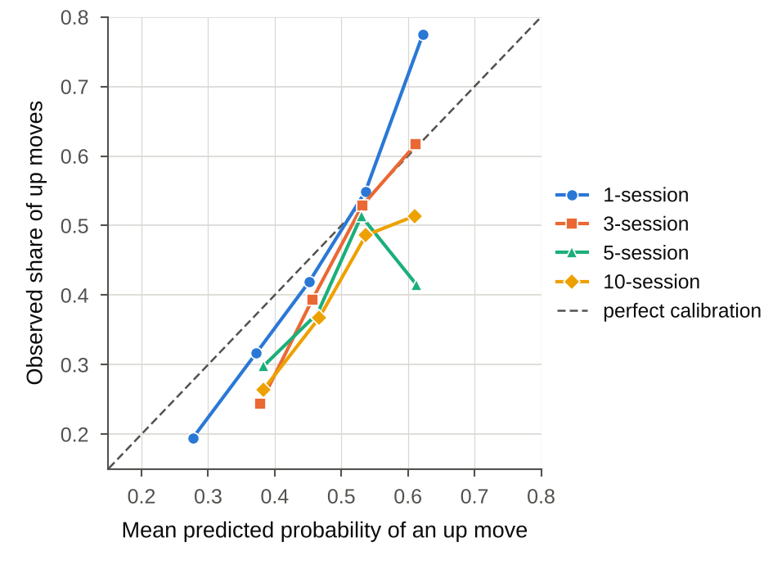
Fig. 3. Reliability of the locked blend on the final test: observed up-frequency against mean predicted probability in ten bins (bins with fewer than 200 predictions omitted).

D. Selective Prediction and the 70% Operating Point
Table IX reports accuracy at each confidence threshold with its coverage, and Fig. 4 shows the full accuracy–coverage curves. At one session, accuracy rises with confidence from 64.0% at ≥ 0.55 (50.1% coverage) to 69.6% at ≥ 0.60 (16.1%), 72.0% at ≥ 0.65 (2.85%) and 81.1% at ≥ 0.70 (0.40%, 243 predictions). Two features of the ≥ 0.70 subset limit what it can show. First, it is concentrated in time: 169 of 243 predictions (69.5%) fall on 9 March 2026, and 85.2% of them were correct; the remaining 74 predictions over 25 dates reach 71.6%. Second, its interval is wide: the 95% block-bootstrap interval is 63.3%–85.2%, and 14.9% of bootstrap replicates fall below 70%, so a true selective accuracy of at least 70% is not established at conventional levels.
Out of fold, the corresponding subset has 1,959 predictions (1.20% coverage) on 157 dates, with accuracy 71.3% (95% CI 62.3%–78.3%; 72.1% excluding its most frequent date, which holds 7.5% of the subset). 97.1% of the ≥ 0.70 test calls are down forecasts, so these selective results largely describe confident down calls in a falling market (the one-session test up-rate is 44.7%).
At three sessions the ≥ 0.65 subset reaches 83.6% on 415 predictions spread over 150 dates (98.8% down calls), which is more stable than the one-session ≥ 0.70 subset, but the corresponding out-of-fold accuracy is only 63.0%, and the ≥ 0.70 subset has 22 predictions. At five and ten sessions the ≥ 0.65 subsets hold 49 and 35 predictions; no five-session prediction and a single ten-session prediction reach 0.70. Overall accuracy never approaches 70%: the model-wide figure is 59.0% at one session.
TABLE IX. CONFIDENCE-THRESHOLD SELECTION AND DATE CONCENTRATION ON THE FINAL TEST
A. Accuracy % of selected predictions (number selected)
Sessions | ≥ 0.55 | ≥ 0.60 | ≥ 0.65 | ≥ 0.70 | Maj. %
1 | 64.0  (30,312) | 69.6  (9,757) | 72.0  (1,725) | 81.1  (243) | 55.3
3 | 66.5  (24,158) | 74.5  (4,520) | 83.6  (415) | 100.0  (22) | 57.3
5 | 65.0  (16,162) | 64.3  (1,391) | 83.7  (49) | –  (0) | 57.3
10 | 59.0  (17,603) | 62.9  (1,445) | 68.6  (35) | 0.0  (1) | 56.8

B. Date concentration of selected predictions
Sessions, τ | Selected | Dates | Top-date share (date) | Acc. % | Acc. % excl. top
1, ≥ 0.55 | 30,312 | 242 | 0.8% (2026-06-01) | 64.0 | 64.3
1, ≥ 0.60 | 9,757 | 241 | 2.5% (2026-03-09) | 69.6 | 69.5
1, ≥ 0.65 | 1,725 | 146 | 12.8% (2026-03-09) | 72.0 | 71.1
1, ≥ 0.70 | 243 | 26 | 69.5% (2026-03-09) | 81.1 | 71.6
3, ≥ 0.65 | 415 | 150 | 5.8% (2026-04-30) | 83.6 | 83.1
3, ≥ 0.70 | 22 | 19 | 9.1% (2026-04-30) | 100.0 | 100.0
Top date = the most frequent date among the selected predictions. The 95% interval for 1 session, ≥ 0.70 is 63.3%–85.2%. Maj. = majority-class accuracy.
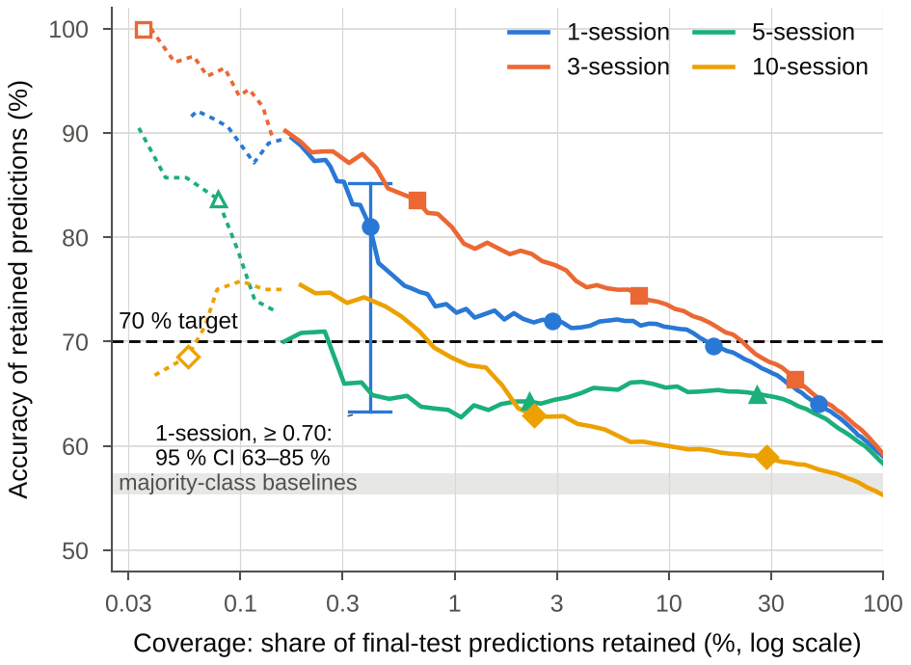
Fig. 4. Selective accuracy against coverage for the locked blend on the final test. Markers show τ = 0.55, 0.60, 0.65 and 0.70; hollow markers and dotted lines have fewer than 100 selected predictions. The vertical bar is the 95% block-bootstrap interval for the one-session ≥ 0.70 subset.

E. Paired Forecast Comparisons
Table X reports Diebold–Mariano comparisons of session-averaged log loss on the final test. The blend is significantly better than the training base rate and than the pre-specified comparator (ExtraTrees) at one and three sessions, and better than the simple average at one session only; at five and ten sessions no comparison survives correction.
TABLE X. DIEBOLD–MARIANO COMPARISONS ON THE FINAL TEST (LOCKED BLEND VERSUS REFERENCE)
Sessions | vs. base rate | vs. best single (ET) | vs. simple average
1 | +0.0145 (< 0.001) | +0.0066 (< 0.001) | +0.0053 (0.02)
3 | +0.0105 (0.006) | +0.0060 (0.001) | +0.0039 (0.87)
5 | +0.0041 (1.00) | +0.0032 (0.35) | +0.0041 (1.00)
10 | −0.0003 (1.00) | −0.0003 (1.00) | +0.0082 (1.00)
Cells give the mean session-level log-loss advantage of the blend (positive = blend better) with the Holm-adjusted one-sided p-value in parentheses (ten comparisons per horizon).

F. Predictor-Family Importance
Table XI reports the increase in development validation log loss when one predictor family is permuted (a single HGB learner on folds 7 and 8, two permutations per family and fold; the test set is never used). The two NEPSE market-state predictors (index return and volatility) dominate at every horizon (17.8 at one session, 36.4 at ten, in units of 10⁻³ log loss), and fundamentals gain weight at five and ten sessions (20.0 and 31.4). Reliance is not skill: final-test accuracy at those horizons is not above the baseline, and slowly changing fundamentals may act as proxies for stock identity or calendar time. The result nevertheless suggests that much of the learned signal is market-level state rather than security selection.
TABLE XI. INCREASE IN VALIDATION LOG LOSS WHEN A PREDICTOR FAMILY IS PERMUTED (×10⁻³)
Family | 1 | 3 | 5 | 10
Returns & momentum | 6.9 | 2.4 | 0.9 | −0.1
Volatility & range | 1.0 | 0.3 | 1.6 | 0.8
Candle shape & gaps | 3.5 | 3.9 | 2.9 | 3.0
Trend & oscillators | 1.4 | 0.3 | 0.7 | 0.2
Liquidity & volume | 1.8 | 1.8 | 2.8 | 1.5
Broker concentration | 3.1 | 3.7 | 2.0 | 2.4
NEPSE market | 17.8 | 11.5 | 34.1 | 36.4
Fundamentals | 3.1 | 4.8 | 20.0 | 31.4
Base validation log loss: 0.6832, 0.6941, 0.6770, 0.6758 at 1, 3, 5 and 10 sessions. Columns are horizons in sessions.

G. Cross-Sectional Ranking and Net-of-Cost Backtest
The pointwise HGB ranker orders securities within each session with a mean rank information coefficient (IC) of 0.284, 0.270, 0.248 and 0.213 at 1, 3, 5 and 10 sessions on the final test (HAC t = 37.5, 24.2, 15.0, 8.6; positive in 98%, 97%, 95% and 93% of sessions), and the top-minus-bottom quintile spread in forward return is 1.02%, 1.45%, 1.67% and 2.04%. These are gross statistics over all eligible securities, including thinly traded ones. An IC of this size and persistence is unusual for daily equity forecasts, and we did not decompose its source; it may arise in thinly traded names that the liquidity filter of the backtest below excludes. We therefore do not treat it as evidence of stock-selection skill.
The backtest is long-only. At each signal session it buys up to ten securities with traded value of at least NPR 1 million whose predicted up-probability is at least τ, entering at the next session's open and exiting at the close of session t + h. Costs per side are 0.36% commission, 0.015% regulator fee and 0.10% slippage, and a 7.5% capital-gains tax applies to positive trades. Signals whose security does not trade at the next session are unfilled (about 3% of signals). Capital is split into h equal tranches that are credited when their positions close, and a random-selection placebo draws the same number of securities per signal session from the same eligible pool. Table XII shows that the one-session strategy is net-negative (a mean of −0.33% per trade at τ = 0.55, interval −0.51% to −0.16%) even though it beats the placebo (−0.78%): the round-trip cost of about 0.95% exceeds the mean gross return of 0.68%. The three- and ten-session strategies at τ = 0.60 are positive on average (+0.55% and +0.52% per trade), but their intervals include zero. Buying every eligible liquid security would have lost 0.85% per one-session trade after costs. A top-ten-by-rank strategy using the ranker has a negative mean at every horizon (−0.53%, −0.41%, −0.43% and −0.40% per trade at 1, 3, 5 and 10 sessions; the interval excludes zero at one and three sessions).
TABLE XII. NET-OF-COST LONG-ONLY BACKTEST ON THE FINAL TEST (LOCKED BLEND)
Sessions | τ | Trades | Net % per trade [95% CI] | Hit % | Cum. % | Placebo %
1 | 0.55 | 1,409 | −0.33 [−0.51, −0.16] | 40.4 | −48.8 | −0.78
1 | 0.60 | 410 | −0.20 [−0.56, +0.20] | 41.2 | −27.0 | −0.65
3 | 0.55 | 1,443 | −0.10 [−0.48, +0.29] | 44.2 | −28.0 | −0.65
3 | 0.60 | 244 | +0.55 [−0.25, +1.41] | 50.4 | +8.2 | −0.37
5 | 0.55 | 1,099 | −0.14 [−0.86, +0.58] | 42.9 | −22.8 | −0.57
5 | 0.60 | 128 | −0.15 [−1.98, +1.44] | 36.7 | −2.1 | −0.43
10 | 0.55 | 1,518 | −0.25 [−1.37, +0.68] | 44.8 | −11.2 | −1.00
10 | 0.60 | 409 | +0.52 [−1.01, +2.21] | 50.4 | +5.2 | −0.27
Net of commission, regulator fee, slippage and capital-gains tax. Cum. = compounded net return of h equal capital tranches, each credited when its positions close; Placebo = mean net return per trade of random picks. No profitability claim is made.

IX. DISCUSSION

A. What the Evidence Supports
Taken together, the evidence supports a modest direction signal at one session in this market and period, and little beyond the base rate at longer horizons. At one session the locked blend beats the majority baseline out of fold in all six folds and on the final test (by 3.6 points: 58.99% against 55.34%), and it beats the base rate in log loss with Holm-adjusted p < 0.001. The importance analysis suggests that this signal rests largely on market-level state. At three sessions the blend improves log loss but not accuracy, and only one of six development folds beats the baseline. At five and ten sessions neither metric supports skill. A reading of the final test alone would suggest otherwise (three-session accuracy of 59.2%), which illustrates why a single window cannot carry a claim.

B. Confidence Is a Coverage–Reliability Trade-off
A 70% confidence requirement can be met only as a selective-prediction operating point. The statement “accuracy is 81% at confidence ≥ 0.70” is true on the final test, but it describes 0.40% of predictions, 70% of which fall on one date; its lower interval bound (63.3%) is below 70%; its out-of-fold counterpart is 71.3% with a lower bound of 62.3%; and 97% of the calls are downward forecasts. The ≥ 0.60 threshold is statistically more informative (9,757 predictions on 241 dates) but its accuracy (69.6%) is below 70%. Selective accuracy therefore has to be reported with its coverage, the number of dates, the share on the most frequent date and an interval; accuracy alone would be misleading.

C. Ensembles and Calibration
Combining learners helped modestly relative to the pre-specified comparator: at one session the blend improves log loss over ExtraTrees by 0.0066 (Holm p = 0.0002) and at three sessions by 0.0060, and not at longer horizons. Out of fold the gain over ExtraTrees was not significant (Holm p = 0.74), and on the test HGB alone scores better than the blend at one and three sessions, so a benefit of ensembling over the strongest single learner is not shown. Log-loss-optimal weighting beat stacking and regime-aware stacking out of fold, but not on the test, where regime awareness hurt. For a blend fitted on log loss, calibration is already close at one session (OOF ECE 0.008); the larger final-test miscalibration (ECE 0.032–0.073) may reflect a shift between development and test conditions, which the Platt and isotonic maps fitted on earlier folds do not repair.

D. Data Lessons for Emerging-Market Forecasting
Several decisions that are invisible in an accuracy table changed what could be trusted: the supplied feature store switches fundamentals before quarter end (99.7% of switches), nine fundamental tables hold only the latest period, the fundamentals table's date column precedes quarter end, 39,500 duplicate transactions appear in a single month, 33,758 dealer-code fields would have been dropped by a numeric-broker filter, and the floorsheet is incomplete in 14 of 97 months. For emerging-market forecasting, source audits, availability dates and an explicit treatment of gaps should be reported as results alongside accuracy. The importance analysis further suggests that the learned signal is largely market-level state, which any security-selection claim has to separate from market timing.

X. LIMITATIONS AND THREATS TO VALIDITY
- Model family: all results are for scikit-learn stand-ins. CatBoost, LightGBM, XGBoost, the Transformer and the TFT-style network were not executed, so the comparison of the named algorithms, and any claim about them, is deferred. Learner settings were fixed rather than tuned, and the MLP early stopping uses a random hold-out.
- Single market and single test window: the 250 final-test sessions (12 October 2025–5 November 2026) cover one regime in which the up-rate was 42.7%–44.7%, and the test is more favourable than the development average (for example 59.2% against 54.1% at three sessions). No second market is used, so cross-market generalisation is not assessed.
- Selective-prediction claims: the 0.70 subsets are small and temporally concentrated, and sixteen threshold-by-horizon looks are reported without a multiplicity correction. The interval for the one-session 0.70 subset does not establish a true accuracy of 70%.
- Label construction: exactly flat outcomes (5.6% of one-session rows) are excluded from training and scoring, which conditions on a future event; reported accuracies apply to sessions in which the price moved. Labels at 3, 5 and 10 sessions overlap, which the block bootstrap and HAC tests handle but which reduces the effective sample size.
- Data: the floorsheet archive is incomplete in 14 of 97 months (largely absent in 12); the 45-day publication lag is an assumption and a longer-lag sensitivity check was not run; corporate-action adjustment for delisted names relies on a jump rule and dividends are not modelled.
- Portfolio validity: the backtest assumes fills at the next open, 10 basis points of slippage, a 7.5% capital-gains tax and at most ten positions per signal session; thin securities may fill worse. It is not a live-trading evaluation and no profitability is claimed. The source of the cross-sectional rank information coefficient was not decomposed.
- Attribution: permutation importance uses one learner and two folds, and no feature-family ablation (a 53-predictor run) was executed.
- Deployment: the earlier companion inference prototype accepts engineered CSV input for a 53-feature schema; it was not updated to the 60-predictor panel and its throughput, latency and security were not benchmarked.

XI. CONCLUSION
This paper presents a leakage-audited workflow that turns 91,048,648 NEPSE floorsheet trades into calibrated multi-horizon direction forecasts and evaluates it with walk-forward validation, an embargo, a locked selection and a single pass over 250 untouched sessions. The workflow validates and de-duplicates the trade archive, constructs 60 point-in-time predictors, excludes two supplied sources that carry look-ahead, and reports every confidence level together with its coverage and date concentration.
On the final test the locked log-loss-weighted blend achieves 58.99% accuracy at one session against a 55.34% baseline (ROC-AUC 0.608, log loss 0.6720), a modest but statistically credible improvement; at 3, 5 and 10 sessions accuracy is not distinguishable from the base rate. The 70% confidence level is reached only as a selective operating point: 81.1% on 243 predictions (0.40% coverage), 69.5% of them on a single date, with an interval (63.3%–85.2%) that does not establish 70%, and a net-of-cost backtest that loses money at one session. The results come from scikit-learn learners; the named gradient-boosting and Transformer models, a feature-family ablation, a longer publication-lag sensitivity check, further test windows and a cross-market comparison remain necessary before any deployment or profitability claim.

ACKNOWLEDGMENT
AI-generated-content disclosure—Claude (Anthropic) was used to write and run the data-cleaning, panel-construction, modelling, calibration, statistical-testing and backtest code described in Sections III–VIII, to prepare Tables I–XII and Figs. 1–4, and to draft and revise the text of Sections I–XI of this version of the manuscript. OpenAI ChatGPT (GPT-6) was used to assist with restructuring and drafting text in the earlier version of the manuscript, with language editing, and with the implementation of the Django inference interface mentioned in Section X. The NEPSE source data were supplied by the authors, and every figure reported in this version was computed by the pipeline from those data. The authors are responsible for verifying the data, code, citations, figures, and all claims in the submitted manuscript.

REFERENCES
[1] V. Tiwari, B. P. Lohani, A. Rana, U. P. Pandey, and B. Dhariwal, “Stock market prediction using different machine learning algorithms,” in Proc. 10th IEEE Uttar Pradesh Section Int. Conf. Electrical, Electronics and Computer Engineering (UPCON), 2023, pp. 147–151, doi: 10.1109/UPCON59197.2023.10434490.
[2] M. Sheeba, D. R. Kumar, S. Kirubakaran, I. Dixit, D. L. Rani, and A. S. Yadav, “An investigation and development into the use of AI-based analytical methods for forecasting the stock market,” in Proc. 4th Int. Conf. Smart Electronics and Communication (ICOSEC), 2023, pp. 1303–1307, doi: 10.1109/ICOSEC58147.2023.10275988.
[3] S. Rout, K. Alaparthi, S. A. A. Sharief, S. Chakka, T. DevaRaj, B. D. Raj, and D. Senapati, “A comparative analysis of different machine learning techniques to predict stock price,” in Proc. Int. Conf. Advancements in Smart, Secure and Intelligent Computing (ASSIC), 2025, doi: 10.1109/ASSIC64892.2025.11158260.
[4] A. S. Crisostomo, C. C. Chaguile, and R. Gustilo, “Stock market prediction using linear regression,” in Proc. 15th IEEE Int. Conf. Humanoid, Nanotechnology, Information Technology, Communication and Control, Environment, and Management (HNICEM), 2023, doi: 10.1109/HNICEM60674.2023.10589227.
[5] S. Udayakumar and E. Anbalagan, “Enhancing stock price forecasts with random forests and simple moving average indicators,” in Proc. Global Conf. Information Technology and Communication Networks (GITCON), Belagavi, India, Aug. 29–31, 2025, pp. 1–6, doi: 10.1109/GITCON65266.2025.11377203.
[6] L. Kotapati, R. B. Sajjala, S. Gudi, B. V. N. Hareesh, S. Tokala, and M. K. Enduri, “Forecasting stock markets trends using machine learning algorithms,” in Proc. 15th IEEE Int. Conf. Computational Intelligence and Communication Networks (CICN), 2023, pp. 278–282, doi: 10.1109/CICN59264.2023.10402238.
[7] S. J. Amruth, T. M. Nigelesh, V. S. Shruthik, V. S. Reddy, and M. Venugopalan, “Time-series-based stock market analysis using machine learning,” in Proc. 15th Int. Conf. Computing, Communication and Networking Technologies (ICCCNT), 2024, doi: 10.1109/ICCCNT61001.2024.10725232.
[8] B. P. Vishwaksena Reddy, S. Nagasai Chandan, Tirumala Y., and Saranya Devi B., “Enhanced stock price prediction using machine learning and deep learning techniques,” in Proc. Int. Conf. Advances in Modern Age Technologies for Health and Engineering Science (AMATHE), 2025, doi: 10.1109/AMATHE65477.2025.11081263.
[9] C. Sekhar and M. Narasimhulu, “Stock market forecasting with ensemble learning: Random forest, XGBoost, and LSTM,” in Proc. 7th Int. Conf. Intelligent Sustainable Systems (ICISS), 2025, pp. 1683–1689, doi: 10.1109/ICISS63372.2025.11076487.
[10] R. M. Kani, K. S. Kumar, J. Y. Gasimov, R. V. S. Praveen, D. J. J. D. Daniel, and K. S. Kumari, “Stock price trend prediction in the banking sector for market analysis and investment decision-making using a hybrid random forest-LSTM model,” in Proc. 3rd World Conf. Communication & Computing (WCONF), Raipur, India, Jul. 25–27, 2025, pp. 1–6, doi: 10.1109/WCONF64849.2025.11233818.
[11] G. Bekaert and C. R. Harvey, “Emerging equity market volatility,” Journal of Financial Economics, vol. 43, no. 1, pp. 29–77, 1997, doi: 10.1016/S0304-405X(96)00889-6.
[12] G. Bekaert, C. R. Harvey, and C. Lundblad, “Liquidity and expected returns: Lessons from emerging markets,” Review of Financial Studies, vol. 20, no. 6, pp. 1783–1831, 2007, doi: 10.1093/rfs/hhm030.
[13] M. López de Prado, Advances in Financial Machine Learning. Hoboken, NJ, USA: Wiley, 2018.
[14] F. X. Diebold and R. S. Mariano, “Comparing predictive accuracy,” Journal of Business & Economic Statistics, vol. 13, no. 3, pp. 253–263, 1995, doi: 10.1080/07350015.1995.10524599.
[15] W. K. Newey and K. D. West, “A simple, positive semi-definite, heteroskedasticity and autocorrelation consistent covariance matrix,” Econometrica, vol. 55, no. 3, pp. 703–708, 1987, doi: 10.2307/1913610.
[16] S. Holm, “A simple sequentially rejective multiple test procedure,” Scandinavian Journal of Statistics, vol. 6, no. 2, pp. 65–70, 1979.
[17] J. C. Platt, “Probabilistic outputs for support vector machines and comparisons to regularized likelihood methods,” in Advances in Large Margin Classifiers, A. J. Smola, P. Bartlett, B. Schölkopf, and D. Schuurmans, Eds. Cambridge, MA, USA: MIT Press, 1999, pp. 61–74.
[18] B. Zadrozny and C. Elkan, “Transforming classifier scores into accurate multiclass probability estimates,” in Proc. 8th ACM SIGKDD Int. Conf. Knowledge Discovery and Data Mining (KDD), 2002, pp. 694–699, doi: 10.1145/775047.775151.
[19] C. Guo, G. Pleiss, Y. Sun, and K. Q. Weinberger, “On calibration of modern neural networks,” in Proc. 34th Int. Conf. Machine Learning (ICML), PMLR vol. 70, 2017, pp. 1321–1330.
[20] R. El-Yaniv and Y. Wiener, “On the foundations of noise-free selective classification,” Journal of Machine Learning Research, vol. 11, pp. 1605–1641, 2010.
[21] D. H. Wolpert, “Stacked generalization,” Neural Networks, vol. 5, no. 2, pp. 241–259, 1992, doi: 10.1016/S0893-6080(05)80023-1.
[22] P. Geurts, D. Ernst, and L. Wehenkel, “Extremely randomized trees,” Machine Learning, vol. 63, no. 1, pp. 3–42, 2006, doi: 10.1007/s10994-006-6226-1.
[23] G. Ke, Q. Meng, T. Finley, T. Wang, W. Chen, W. Ma, Q. Ye, and T.-Y. Liu, “LightGBM: A highly efficient gradient boosting decision tree,” in Advances in Neural Information Processing Systems 30 (NIPS), 2017, pp. 3146–3154.
[24] H. R. Künsch, “The jackknife and the bootstrap for general stationary observations,” The Annals of Statistics, vol. 17, no. 3, pp. 1217–1241, 1989.
[25] D. Harvey, S. Leybourne, and P. Newbold, “Testing the equality of prediction mean squared errors,” International Journal of Forecasting, vol. 13, no. 2, pp. 281–291, 1997, doi: 10.1016/S0169-2070(96)00719-4.
[26] F. Pedregosa et al., “Scikit-learn: Machine learning in Python,” Journal of Machine Learning Research, vol. 12, pp. 2825–2830, 2011.
[27] L. Prokhorenkova, G. Gusev, A. Vorobev, A. V. Dorogush, and A. Gulin, “CatBoost: Unbiased boosting with categorical features,” in Advances in Neural Information Processing Systems 31 (NeurIPS), 2018, pp. 6638–6648.
[28] T. Chen and C. Guestrin, “XGBoost: A scalable tree boosting system,” in Proc. 22nd ACM SIGKDD Int. Conf. Knowledge Discovery and Data Mining (KDD), 2016, pp. 785–794, doi: 10.1145/2939672.2939785.

